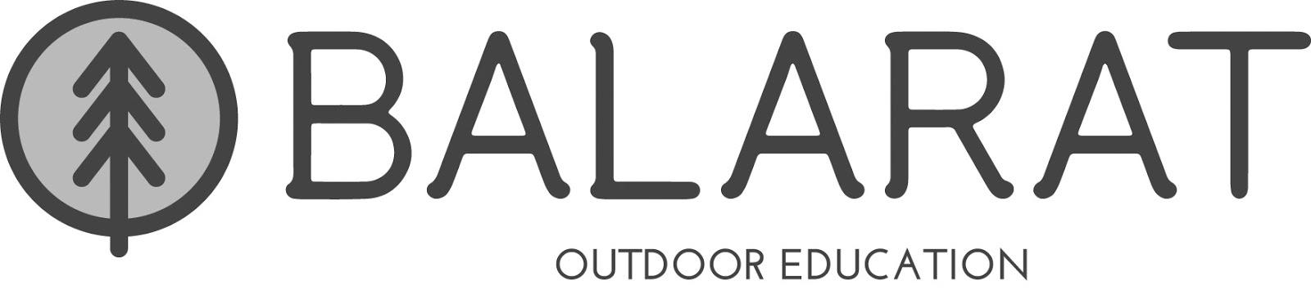

Registration Form 2-day

Student’s Name_______________________________________Date of Birth________________ Student ID # ____________________________
School__________________________________________________________________________________________________________________ Teacher_________________________________________________________________________________________________________________
Student’s Address_____________________________________________________________________________ Zip Code____________________
Parent/Legal Guardian Name___________________________________________________________________________________________________________________
Home Phone_______________________________ Work Phone _____________________________Cell Phone _____________________________
Second Parent/Legal Guardian Name ________________________________________________________________________________________________________________________
Home Phone_______________________________ Work Phone ____________________________Cell Phone ______________________________
Emergency Contact Name ________________________________________________________________________________________________________________________
Home Phone________________________________ Work Phone ____________________________Cell Phone _____________________________
EMERGENCY PROCEDURES
Any child who appears to be ill or has had an accident will be closely checked and observed by the Balarat staff member present. In consultation with parents and the classroom teacher, the Balarat staff person in charge will make the final decision as to appropriate action. If the child has to be returned home, the following steps will be taken:
1. The Balarat staff person in charge will contact the parent/guardian regarding the illness or injury.
2. The Balarat staff person in charge will make the necessary transportation arrangements for the child.
3. The parent or legal guardian must make necessary arrangements at home to receive the child.
If the parent or legal guardian cannot be notified and immediate medical care is indicated, special emergency care and/or evacuation will be arranged through the Balarat staff, and/or emergency medical services. Please note that the Denver Public Schools does not assume financial responsibility for any medical costs that may be incurred.

To my knowledge, this student is in satisfactory health to fully participate in this activity. If he/she has diabetes, epilepsy, allergies, heart disease, or any other physical condition that requires daily medications or special attention, I have given directions.

I give permission for my child to participate in the program at Balarat from (Date) ___________________to (Date) __________________.
By signing this registration form I certify that the information provided is accurate.

By signing this registration form I certify that the information provided is accurate. Further, I authorize the release of my son’s/daughter’s Free/Reduced Lunch eligibility status to Balarat. Your child’s lunch eligibility status will be held in confidence by the Balarat staff and used solely for certifying payment criteria for meals at Balarat.

The Balarat food prices are related to your child’s lunch eligibility status. Your child’s lunch eligibility status will be held in confidence by the Balarat staff and will be used solely for certifying payment criteria for meals at Balarat.

Please check the appropriate amount to cover your student’s food costs.
____ $16.75 (full pay) ____ $13.75 (reduced) ____$13.00 (free lunch)
Please pay in cash or write a check to your student’s school for the amount you owe.
Signature of Parent or Guardian _______________________________________________Date ____________________________
Print Name_________________________________________________Relationship to Child ______________________________
** Continue on the back of this page**
Allergies  Does your child Have any allergies (circle one)  No Yes  If Yes, what is the allergen? ______________  What happens when they come into contact with the allergen? _____________________________________________  _____________________________________________  Do they have medication for this allergy?  __________________________________________  __________________________________________ | Medications  Is your child currently taking any medication (circle one)  No Yes  If Yes, please attach a DPS Student Medication Request Release Agreement for each medication taken.  Any medicine given while at Balarat must be in a prescription bottle and be accompanied by a current (within 20 days) written order from the student’s physician and a written request from the parent or guardian to administer the medication.
Physical Disability  Please list any non-allergy physical or medical conditions that would be helpful for us to know about your child.  ______________________________________________________________________________________________________________________________________________________________________________________________________________________________________________________________________________________________________________________________ | Special Dietary Needs  Please indicate below if your child has special dietary needs due to health conditions, allergies, or religious practice, (NOT food preferences). If there is a dietary issue please let your classroom teacher and the Balarat office know 2 weeks in advance of the trip so we can plan accordingly. Our kitchen staff can accommodate many dietary needs, but not without knowing of these needs well beforehand. Students may need to bring their own food for dietary needs.
 | Circle any that apply
 | Vegetarian  Vegan  No pork  No red meat  No peanuts | No tree-nuts  No dairy  No wheat/gluten  Other: __________________

---------Parent Permission for Media (Photos & Video) ------------

Permission for photographs and interviews of students under 18 years of age can be granted to the media ONLY with parent approval. These photographs, written interview quotes and verbal interview statements will appear in information about DPS programs and people. I understand that the DPS shall not be liable for royalties, commissions, or payments of any nature to me or my child in connection with such filming, photographing, and/or interviewing. DPS assumes no liability of any nature in connection with such filming and/or interviewing.

I hereby do __________ do not _________ give my permission to DPS to allow my child to be filmed/photographed and interviewed by media.

Signature of Parent/Guardian: _____________________________________________Date: _______________________________
**Please read and sign the front of this page **

